## **Objectives**

* Explain React State

In this hands-on lab, you will learn how to:

* Use React State object

## **Prerequisites**

The following is required to complete this hands-on lab:

* Node.js
* NPM
* Visual Studio Code

## **Notes**

Estimated time to complete this lab: **60 minutes.**

Create a React App “counterapp” which will have a component named “CountPeople” which will have 2 methods.

UpdateEntry() 🡪 which will display the number of people who entered the mall.

UpdateExit() 🡪 which will display the number of people who exited the mall.

Use Constructor and state to Store the entrycount and exitcount.

The component has 2 buttons

1. Login 🡪 when clicked, the entrycount should get incremented by 1
2. Exit 🡪 when clicked, the exitcount should get incremented by 1

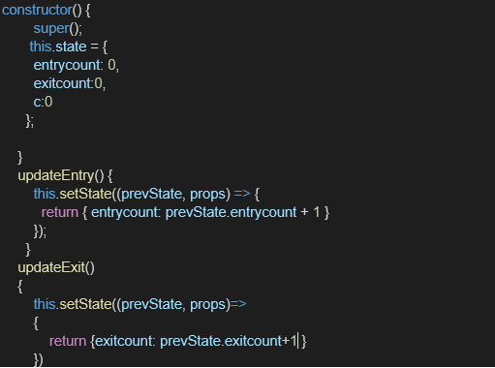

The output should be as follows:

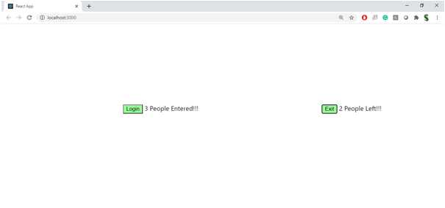

**Solution :**

Step 1: Create a React App In your terminal:

npx create-react-app counterapp cd counterapp code .

Step 2: Create CountPeople.js Component Create file: src/CountPeople.js

import React, { Component } from 'react';

class CountPeople extends Component {

constructor(props) {

super(props);

this.state = {

entryCount: 0,

exitCount: 0

};

}

updateEntry = () => {

this.setState((prevState) => ({

entryCount: prevState.entryCount + 1

}));

};

updateExit = () => {

this.setState((prevState) => ({

exitCount: prevState.exitCount + 1

}));

};

render() {

return (

<div style={{ padding: '20px', textAlign: 'center' }}>

<h2>Mall Visitor Counter</h2>

<p>👥 People Entered: {this.state.entryCount}</p>

<p>🚪 People Exited: {this.state.exitCount}</p>

<button onClick={this.updateEntry} style={{ margin: '10px', padding: '10px' }}>

Login

</button>

<button onClick={this.updateExit} style={{ margin: '10px', padding: '10px' }}>

Exit

</button>

</div>

);

}

}

export default CountPeople;

Step 3: Modify App.js Edit src/App.js:

import React from 'react';

import './App.css';

import CountPeople from './CountPeople';

function App() {

return (

<div className="App">

<CountPeople />

</div>

);

}

export default App;

Step 4: Run the Application

npm start

Expected Output Initially:

People Entered: 0

People Exited: 0